BioPhys 3G03 – Assignment 2 – Jatin Chowdhary – February 10th 2022

Question 1)
The values for dt and E, for each iteration are:
dt = 1, E = 3732.024788888908
dt = 0.5, E = 1840.7019239566425
dt = 0.2, E = 750.6918114293936
dt = 0.1, E = 388.86996433102297
dt = 0.05, E = 197.83494025608798
dt = 0.02, E = 79.95652797514977
dt = 0.01, E = 40.1163702727105
dt = 0.005, E = 20.092838473780535
dt = 0.002, E = 8.045470342534554
dt = 0.001, E = 4.024125928552825

Plotting the values above on a log-log plot yields the following graph:
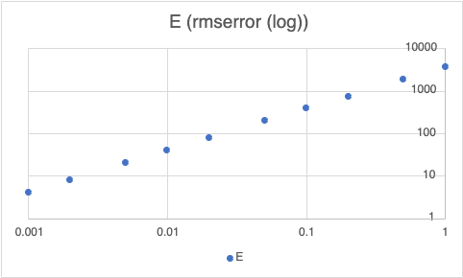

As evident by the graph above, a straight line with a slope of 1, cuts through all the points on the graph. This means that E is proportional to dt to the power 1, when dt is small.

Question 2)
After calculating the error E in both methods over the range of dt, we get the following graph:
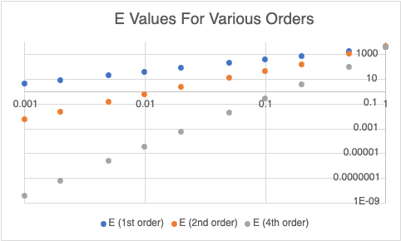

The graph is a log-log plot with straight lines, with a slope of 1, running through the data, which demonstrates that E scales as dt^2 for the second-order method and dt^4 for the fourth-order method.

